EXP 25: Create and Configure a New VM Image in Azure (Demonstrating DaaS)

Aim:
To create and configure a virtual machine (VM) image on Microsoft Azure and use it to deploy a database service, demonstrating Database as a Service (DBaaS).
Procedure (Step-by-Step)
Step 1: Log in to Azure Portal
- Go to https://portal.azure.com
- Sign in with your Azure account.

Step 2: Create a Resource Group
- Search for Resource Groups → Click Create.
- Fill details:
  - Resource Group Name: VM_DBaaS_RG
  - Region: Nearest available region
- Click Review + Create → Create.

Step 3: Create a Virtual Machine
- Search for Virtual Machines → Click Create → Azure Virtual Machine.
- Fill the Basics tab:
  - Subscription: Azure for Students / Free Tier
  - Resource Group: VM_DBaaS_RG
  - VM Name: DBServerVM
  - Region: Same as resource group
  - Image: Choose an OS (e.g., Ubuntu 22.04 LTS or Windows Server 2022)
  - Size: Select minimum CPU/RAM (e.g., B1s – 1 vCPU, 1 GB RAM)
  - Username/Password: Enter admin credentials
- Disks: Keep default (SSD)
- Networking: Allow public inbound ports → SSH (Linux) or RDP (Windows)
- Click Review + Create → Create.

Step 4: Connect to the Virtual Machine
- For Linux VM → Use SSH:
ssh username@PublicIP
- For Windows VM → Use RDP client with VM IP address.

Step 5: Install Database Server
- Linux VM (Example MySQL):
sudo apt update
sudo apt install mysql-server -y
sudo systemctl start mysql
sudo systemctl enable mysql
- Windows VM (Example SQL Server Express):
  - Download SQL Server Express installer and install.
  - Configure authentication mode and admin credentials.
Step 6: Configure Database
- Login to the database and create a sample database
Step 7: Create a VM Image
- Stop the VM from the Azure portal (Stop → Deallocate).
- Navigate to the VM → Capture.
- Fill the details:
  - Image Name: DBServerVMImage
  - Resource Group: Choose same or new
  - Automatically delete VM after creating image: Optional
- Click Create.
- Now you have a reusable VM Image with the database pre-installed.

Step 8: Deploy a New VM from the Image
- Go to Images → Select DBServerVMImage → Create VM
- Fill the same details as before.
- The new VM will have database server ready to use → Demonstrates DBaaS.
Step 9: Verification
- Connect to the new VM → Open database → Run queries to check tables and data.

Output:
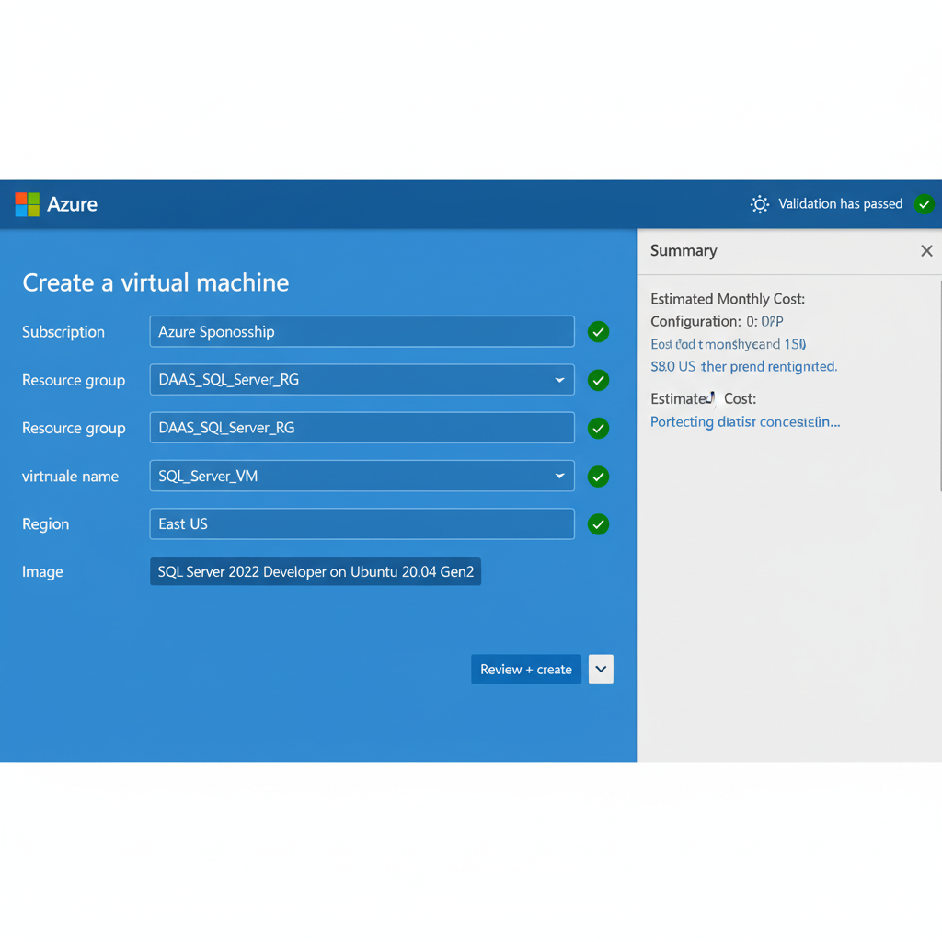

Result:
A virtual machine image with a configured database server was successfully created in Azure. Using this image, new VMs can be deployed quickly with the database service ready, demonstrating DBaaS functionality.

